ER-Diagram:
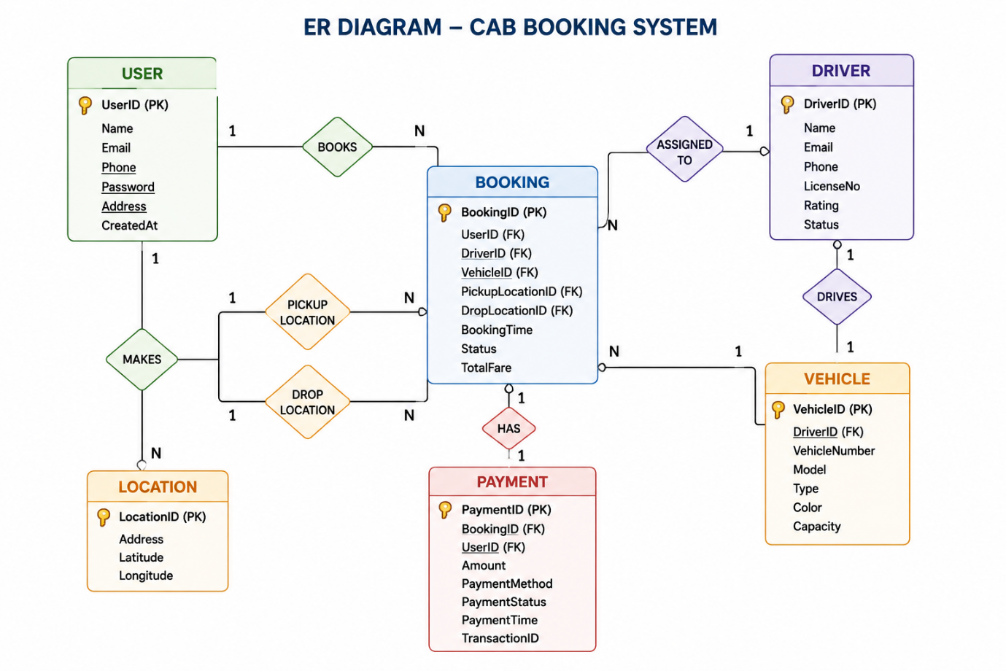
User – Booking Relationship
Type: One-to-Many
Meaning: One user can create multiple cab bookings, while each booking belongs to only one user.
How it's stored: The Booking collection contains a UserID that references the user who booked the ride.
Example: A passenger can book multiple rides on different days, and each booking is linked to that passenger.

Driver – Booking Relationship
Type: One-to-Many
Meaning: One driver can complete many bookings, while each booking is assigned to only one driver.
How it's stored: The Booking collection stores a DriverID that identifies the assigned driver.
Example: A driver accepts several ride requests throughout the day, with each booking associated with that driver.

Booking – Payment Relationship
Type: One-to-One
Meaning: Every completed booking has one corresponding payment record, and each payment belongs to one booking.
How it's stored: The Payment collection stores a BookingID that references the completed booking.
Example: After a ride is completed, the passenger makes a payment, and a payment receipt is generated for that booking.

Driver – Vehicle Relationship
Type: One-to-One
Meaning: Each driver is assigned one vehicle, and each vehicle is associated with one driver.
How it's stored: The Vehicle collection stores a DriverID as a reference.
Example: A registered driver operates one assigned cab for providing ride services.

Admin – Booking Relationship
Type: One-to-Many
Meaning: The administrator can manage multiple bookings, users, and drivers through the admin dashboard.
How it's stored: The Admin module accesses and manages data from the Users, Drivers, Bookings, and Payments collections.
Example: An administrator monitors ride requests, verifies drivers, and resolves customer issues from a centralized dashboard.

